* It is not hospice
* It is not only for people who are dying

|  |  |
| --- | --- |
| Palliative Care | Hospice |
| -For all seriously ill patients, regardless of prognosis  -Patient can receive curative care at the same time with your provider  -Palliative care team works with a variety of health providers including specialist and primary care physicians to prevent service fragmentation  -New, evolving, resulting in different features among palliative programs  -Inpatient services are covered as part of the hospitalization. Outpatient services are typically billed and covered in a similar way to other outpatient visits | -Six month prognosis required by Medicare and other funders  -Coverage includes outpatient medications and supplies, but treatments to cure or prolong life are not covered  -Hospice Team coordinates and oversees the plan of care  -Medicare covers all or most of the services related to the hospice diagnosis  -Medicaid and most major insurance companies also offer hospice coverage  -No one will be turned over for inability to pay |

Tioga Medical Center has partnered with the Center for Rural Health University of North Dakota School of Medicine and Health Sciences to bring palliative care to our patients during a serious illness; it’s the extra layer of support in your bridge.

#### Re-enforcing your bridge of support

[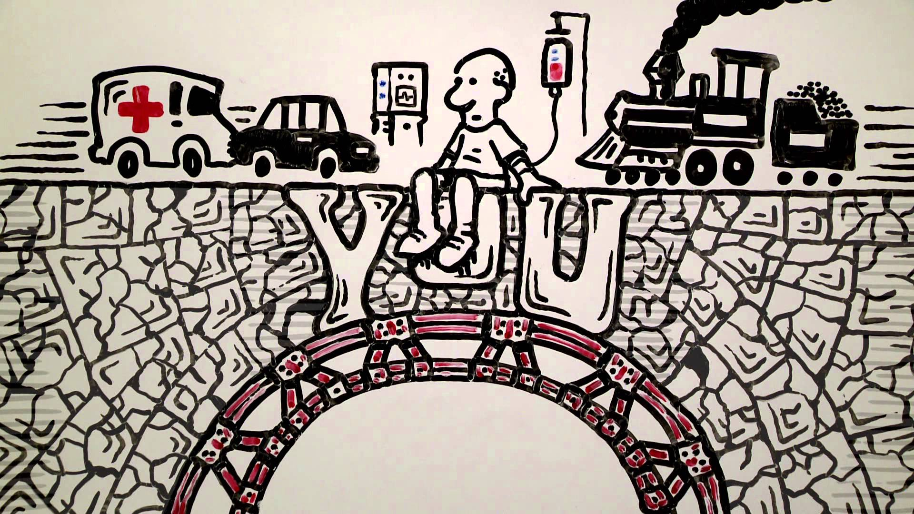](https://www.google.com/url?sa=i&rct=j&q=&esrc=s&source=images&cd=&cad=rja&uact=8&ved=2ahUKEwiS4YDrru3cAhWF7IMKHYRxDmcQjRx6BAgBEAU&url=https://www.youtube.com/watch?v%3DlDHhg76tMHc&psig=AOvVaw170CrDa_mIGsbxzsU3ZWVB&ust=1534364362448589)

****Palliative Care

**Re-enforcing your bridge of support**

Tioga Medical Center

810 N Welo Street

PO Box 159

Tioga, ND 58852

Phone: 701-664-3305

[www.tiogahealth.org](http://www.tiogahealth.org)

Giving Hearts Home Care LLC

5 1st Ave SE

Stanley, ND 58784

Phone: 701-313-0229

[givingheartshomecare@yahoo.com](mailto:givingheartshomecare@yahoo.com)

Home Helpers

817 Main Street

Williston, ND 58801

Phone: 701-572-4357

[KaitlynErdman@hoehelpershomecare.com](mailto:KaitlynErdman@hoehelpershomecare.com)

Visiting Angels

1524 South Broadway, Ste 6A

Minot, ND 58701

Phone: 701-852-2636

[www.VisitingAngels.com](http://www.VisitingAngels.com)

Some other helpful palliative resources in our community are local churches, pastors, pharmacy, ambulance, fire, police, and other social entities.

### Palliative Care Service Options:

### What palliative care is not?

### Where to find palliative care?

* In hospitals
* In home care programs
* In clinics
* In nursing homes
* In our community
* Relieves discomfort
* Decreases other symptoms, such as shortness of breath, fatigue, nausea, loss of appetite, difficulty sleeping, and stress
* Helps both patients and families
* Leads to better quality of life
* Communication
* Makes a plan for now and the future
* Coordinates the plan across settings of care (hospital, clinic, nursing home, home health, spiritual support)

### What does palliative care look like?

* People (adults and children) with serious illness (e.g., lung, heart, cancer)
* People with disease related symptoms
* People who are in and out of the hospital or emergency room

### Together we can make sure your bridge of support is strong.

* Complete a North Dakota POLST: Physician Orders for Life Sustaining Treatment
* The goal of POLST is to effectively communicate the wishes of patients facing serious illness or end of life: to have OR to limit medical treatment as they move from one care setting to another.
* This is a standardized form that can be used throughout North Dakota and many other states
* The POLST is to be used in conjunction with your advanced directives
* The North Dakota POLST form can be found at the Tioga Medical Center and outreach clinics or at <https://www.honoringchoicesnd.org/polst/>
* After you have completed the POLST and your medical provider has signed it remember to provide a copy to all of your medical care facilities
* Disease related and other symptoms are often not well managed
* Our health care system is not designed to support patients and families with chronic/serious illness
* Hospice focuses specifically on end- of-life care rather than the needs of people with serious, long-term illness

### Why is palliative care needed?

* Palliative care is medical care for people with serious illness of any stage and at any age
* The goal of palliative care is the best quality of life for patients with serious illness and their families
* It is provided at the same time as other medical treatments

### How to prepare yourself?

### Who should receive palliative care?

### What is palliative care?